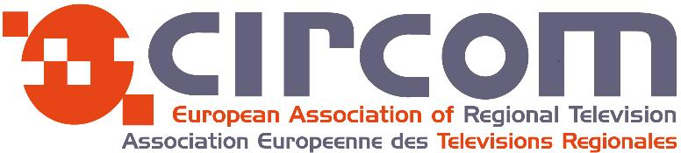

APPLICATION FORM for the Webinar:

FUTURE FUNDING OF PSM
and it’s impact on our regional output
Thursday 24TH September 2020
10 :00hrs (CET) / 09 :00hrs (GMT)
(Via TEAMS)

Course Leader: Dr. Zoran Medved

All you have to do is to send us your email address and we will send you an invitation to allow you to connect to the webinar.

There are 16 or more places available for employees of CIRCOM member stations.

PERSONAL DETAILS:

Mr Mrs

First name:

Surname:

Job Title:

Your Mobile Phone Number:

Your email address:

Name of your CIRCOM Regional National Co-ordinator:

Please note: Applicants must have a good command of spoken English
(This is really important as this webinar is about ideas so you need to feel confident when expressing yourself in English).

PLEASE RETURN THE APPLICATION FORM BY EMAIL TO:

Email: lucie.durand@circom-regional.eu and lucie.durand@francetv.fr

DEADLINE : Monday 21st September 2020.

